**Adding Professional Email to your phone.**

To set up Gmail on Android automatically:

1. Open Gmail.
2. In the top right corner, tap your profile picture and tap **Add another account**.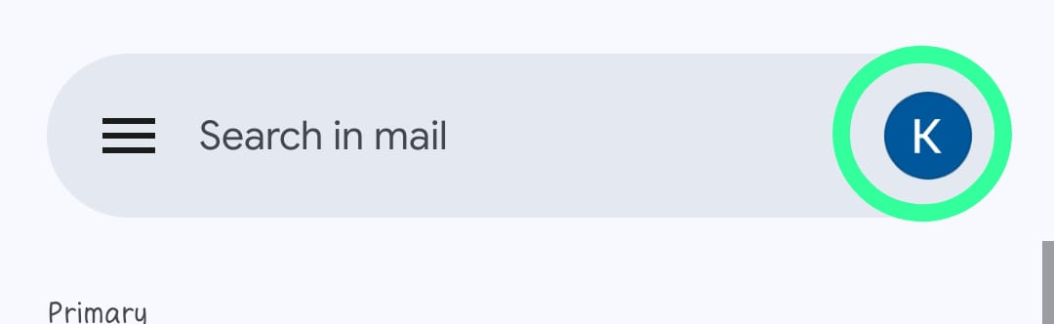
3. Choose “Other”.

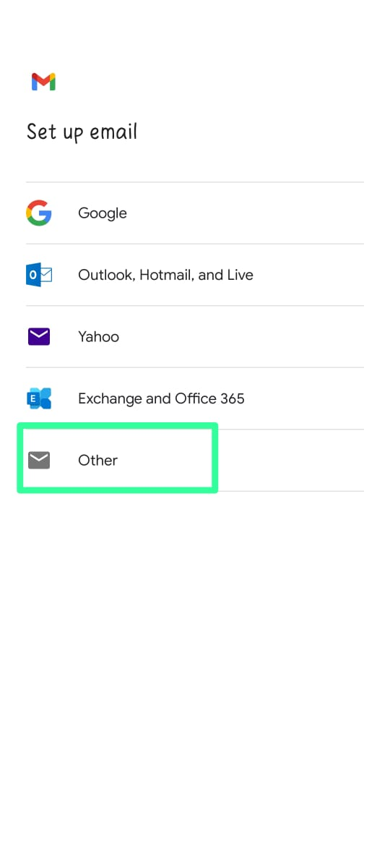

1. Enter your email address and tap **Next**.

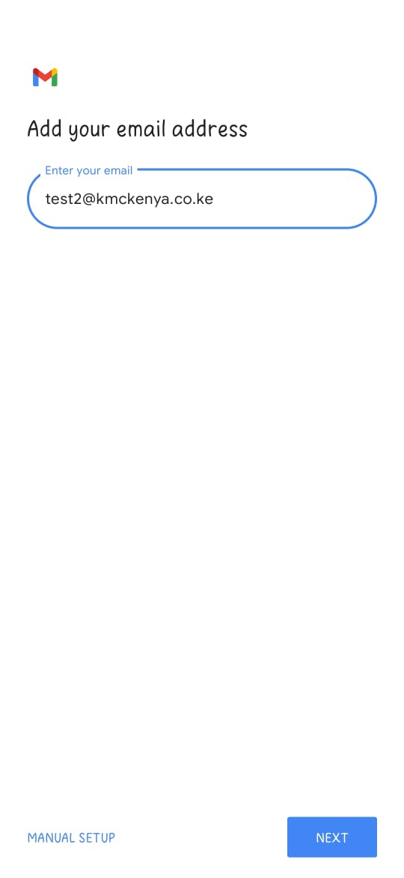

1. Choose the account type and tap **Next**. To keep the copies of email messages on the server, select the **IMAP** option. If you do not want to keep them on the server, select **POP3**.

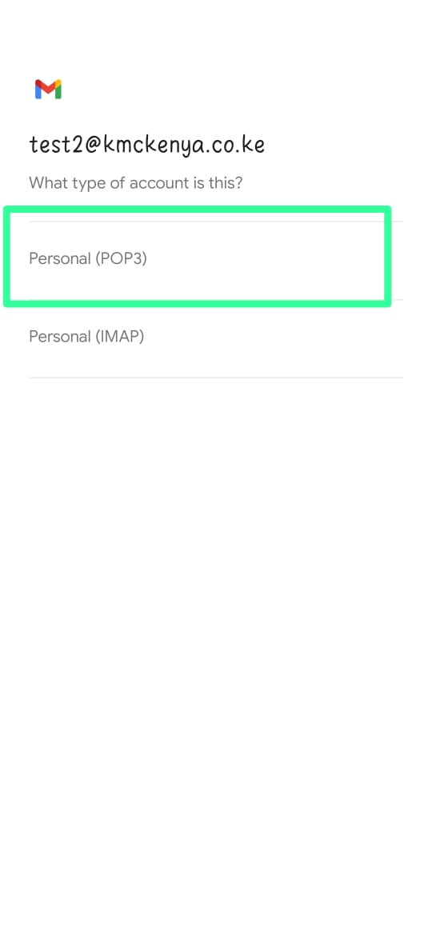

1. Specify your email account password and tap **Next**.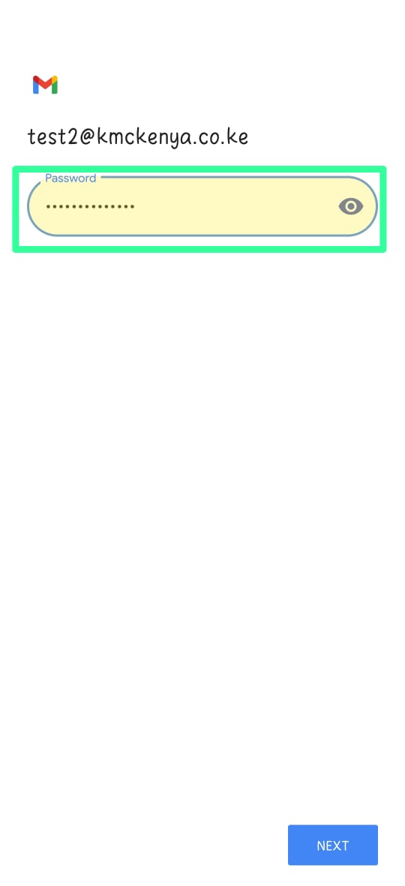
2. The application will automatically fetch the incoming server settings. Select whether deleting emails from Inbox will also delete them from your Plesk server or not and tap **Next**.

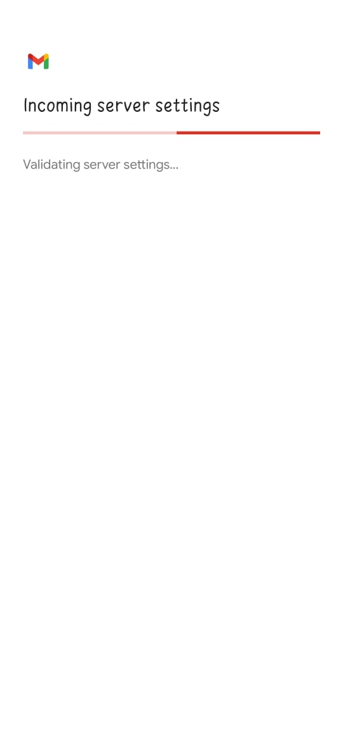

1. **Note:** You may see the “Certificate not valid” warning if the mail server or domain is not secured with a valid SSL/TLS certificate. To proceed via HTTP, tap **Advanced** and then tap **PROCEED ANYWAY**.
2. The application will automatically fetch the outgoing server settings. Tap **Next**.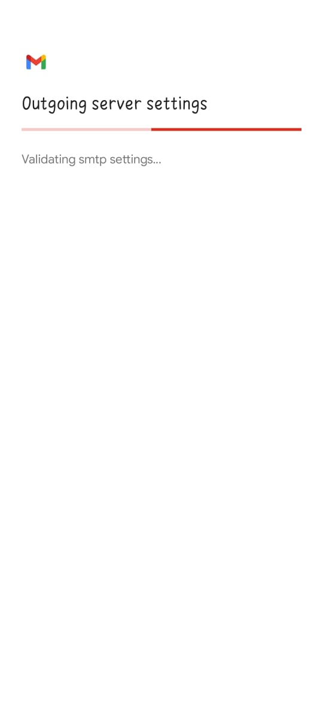

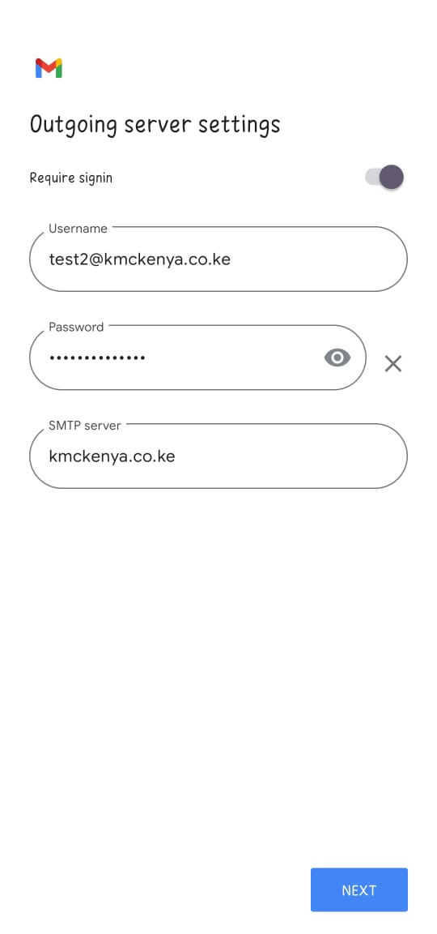

1. **Note:** Here you may see the “Certificate not valid” warning again. To proceed via HTTP, tap **Advanced** and then tap **PROCEED ANYWAY**.
2. Keep the default Gmail sync settings or change them and tap **Next**.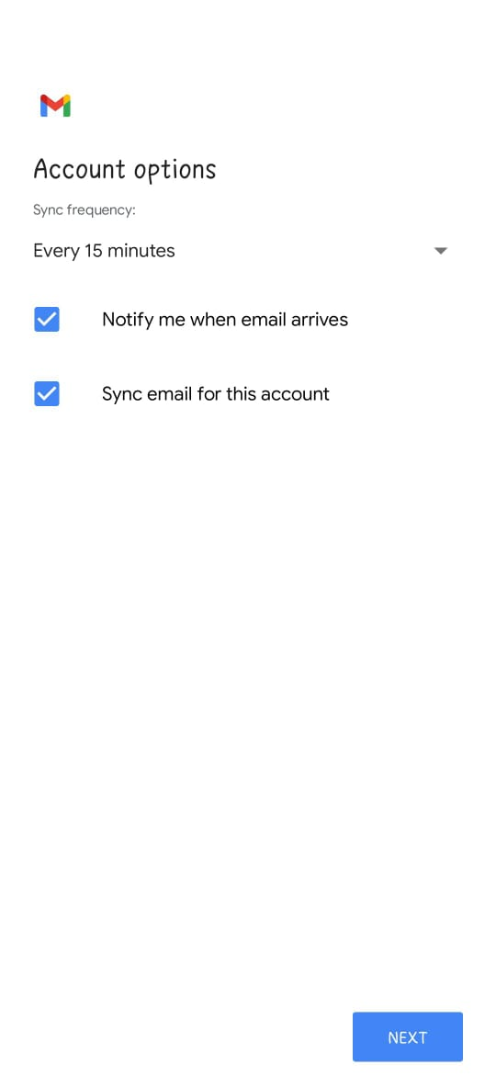
3. Set your full name in the “Your name” field. (Optional) Change the account name and/or specify the name that will be displayed on sent messages.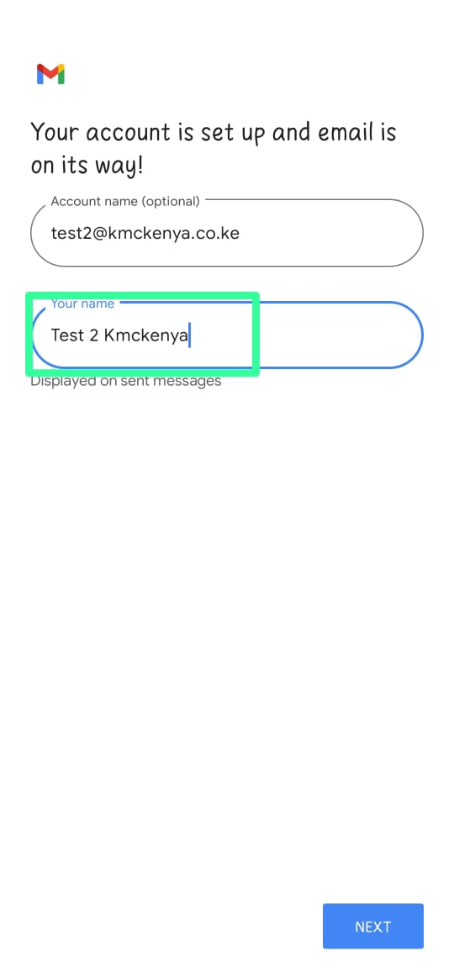
4. Tap **Next** to exit the setup.
5. The setup is done. You can see the new account in the list of accounts in Gmail.